

Question Bank

# CO1: Understand various software engineering principles and their application

## Short/Long Questions:

1. **Explain the importance of software engineering in real-life projects.**

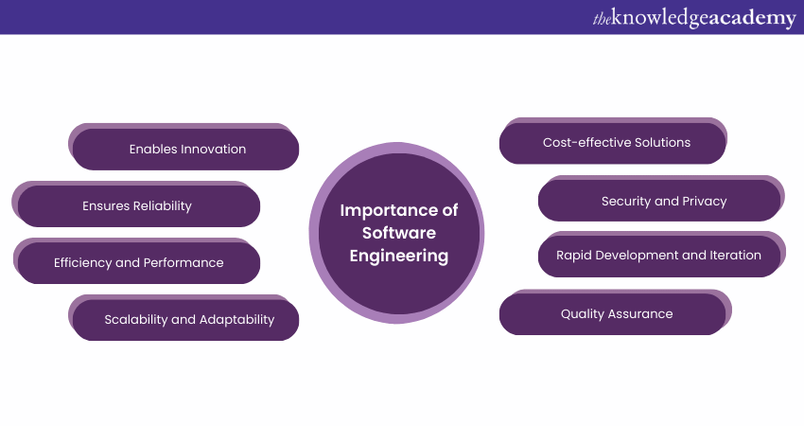

Software Engineering is the process of systematically designing, developing and maintaining software. It involves understanding and documenting the software's requirements, creating a design and architecture, writing the code, and ensuring the software's quality through [testing](https://www.theknowledgeacademy.com/blog/what-is-software-testing/) and quality assurance. Software Engineering aims to produce reliable, efficient, and scalable software systems.

**1) Enables Innovation:**Software Engineering is at the heart of innovation in technology. It allows us to create new applications, products, and services that drive progress and improve our lives.

**2) Ensures Reliability:** Proper Software Engineering practices lead to more reliable and stable software, reducing the likelihood of crashes, errors, and system failures. This is crucial for critical applications in healthcare, transportation, and finance.

**3) Efficiency and Performance:** Well-engineered software is optimised for efficiency and performance. It can handle tasks faster, consume fewer resources, and deliver a better user experience.

**4) Scalability and Adaptability:**Software Engineering principles facilitate the development of scalable software that can grow with increasing demands. It also allows for easy adaptation to changing requirements and technologies.

**5) Cost-effective Solutions:** Investing in Software Engineering upfront can lead to cost savings in the long run. Properly designed and maintained software requires fewer resources for maintenance and support.

**6) Security and Privacy:**Software Engineering practices include security considerations, helping to protect data and systems from [cyber threats](https://www.theknowledgeacademy.com/blog/what-is-cyber-security-attack/). This is particularly crucial in an era of increasing digital vulnerabilities.

**7) Rapid Development and Iteration:** Modern Software Engineering methodologies, such as [Agile](https://www.theknowledgeacademy.com/blog/what-is-agile/) and [DevOps](https://www.theknowledgeacademy.com/blog/what-is-devops/), enable rapid development and iterative improvements, ensuring that software can keep up with evolving user needs.

**8) Quality Assurance:**Software Engineering incorporates quality assurance processes and testing to identify and address defects, ensuring that the final product meets high standards.

1. **Discuss different software development life cycle models with diagrams.**

**SDLC is a process followed for software building within a software organization.**SDLC consists of a precise plan that describes how to develop, maintain, replace, and enhance specific software.

**1. Agile Model**

[**Agile Development Model**](https://www.geeksforgeeks.org/software-engineering-agile-development-models/) is a combination of iterative and incremental models, that is, it is made up of iterative and incremental models.

* In Agile model, focus is given to process adaptability and customer satisfaction.
* In earlier times, iterative waterfall model was used to create software. But in today's time developers have to face many problems. The biggest problem is that in the middle of software development, the customer asks to make changes in the software. It takes a lot of time and money to make these changes. So to overcome all these shortcomings, the agile model was proposed in the 1990s.

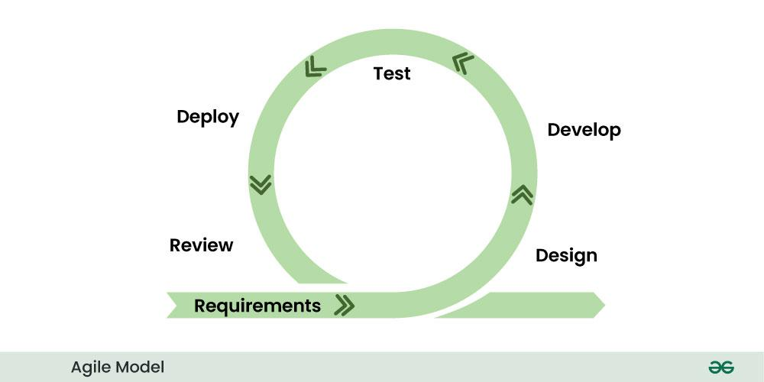The Agile Model was created mainly to make changes in the middle of **software development** so that the software project can be completed quickly.

**2. Waterfall Model**

[**Waterfall Model**](https://www.geeksforgeeks.org/waterfall-model/) is a famous and good version of [**SDLC(System Development Life Cycle)**](https://www.geeksforgeeks.org/software-development/)for software engineering. The waterfall model is a linear and sequential model, which means that a development phase cannot begin until the previous phase is completed. We cannot overlap phases in waterfall model.

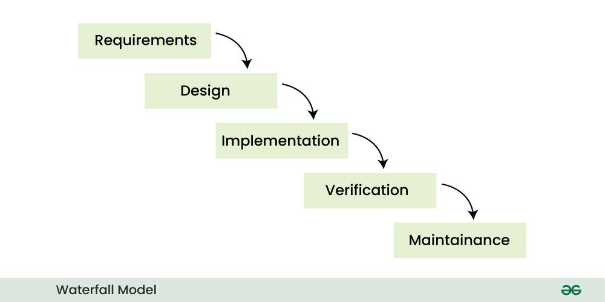**Phases of Waterfall model**

**3. V-Model**

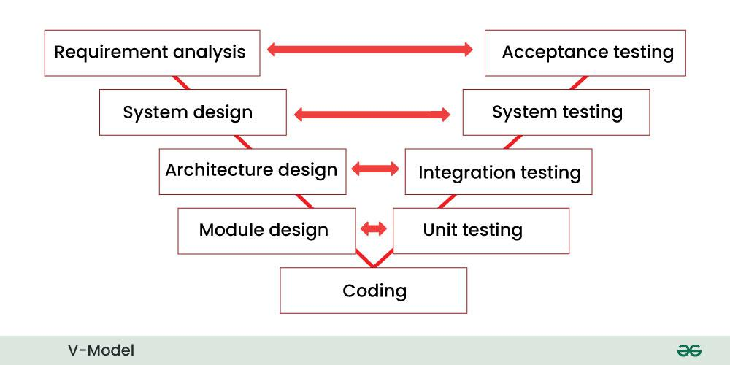[**V-Model**](https://www.geeksforgeeks.org/software-engineering-sdlc-v-model/)is an SDLC model, it is also called Verification and Validation Model. V-Model is widely used in the **Software Development Process**, and it is considered a disciplined model. In V-Model, the execution of each process is sequential, that is, the new phase starts only after the previous phase ends.

**4. Incremental Model**

In [**Incremental Model**](https://www.geeksforgeeks.org/software-engineering-incremental-process-model/), the **Software Development Process**is divided into several increments and the same phases are followed in each increment. In simple language, under this model a complex project is developed in many modules or builds.

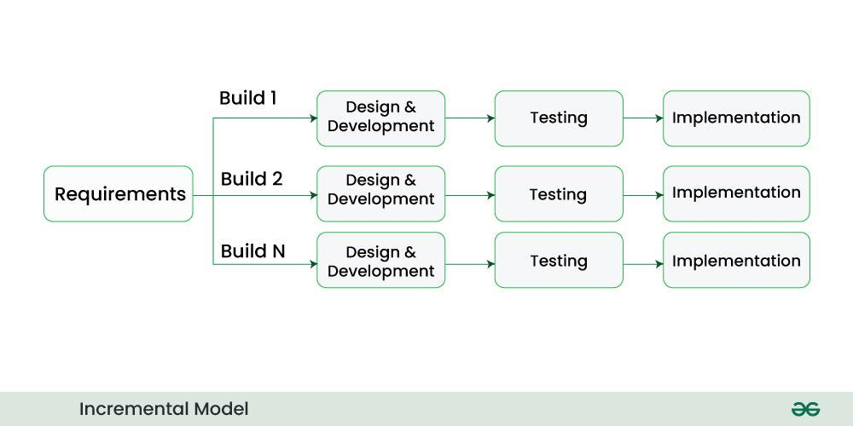

**5. RAD Model**

[**RAD Model**](https://www.geeksforgeeks.org/software-engineering-rapid-application-development-model-rad/) stands for rapid application development model. The methodology of RAD model is similar to that of incremental or waterfall model. It is used for small projects.

The main objective of RAD model is to reuse code, components, tools, processes in project development.

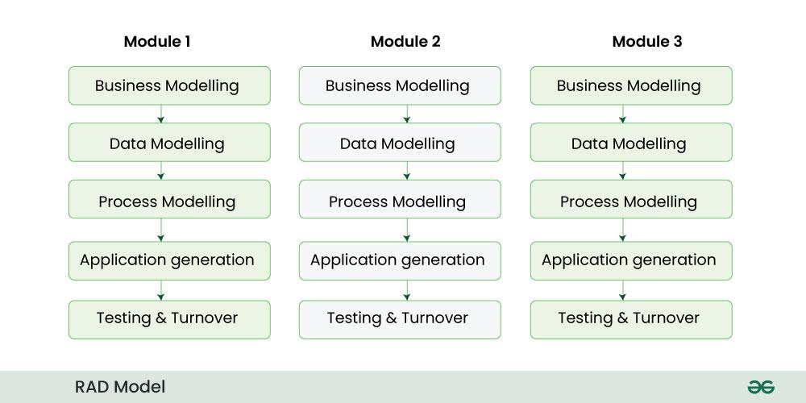

**6. Iterative Model**

In [Iterative Model](https://www.geeksforgeeks.org/software-engineering-iterative-waterfall-model/) we start developing the software with some requirements and when it is developed, it is reviewed. If there are requirements for changes in it, then we develop a new version of the software based on those requirements. This process repeats itself many times until we get our final product.

Through this diagram you can understand the Interactive model.

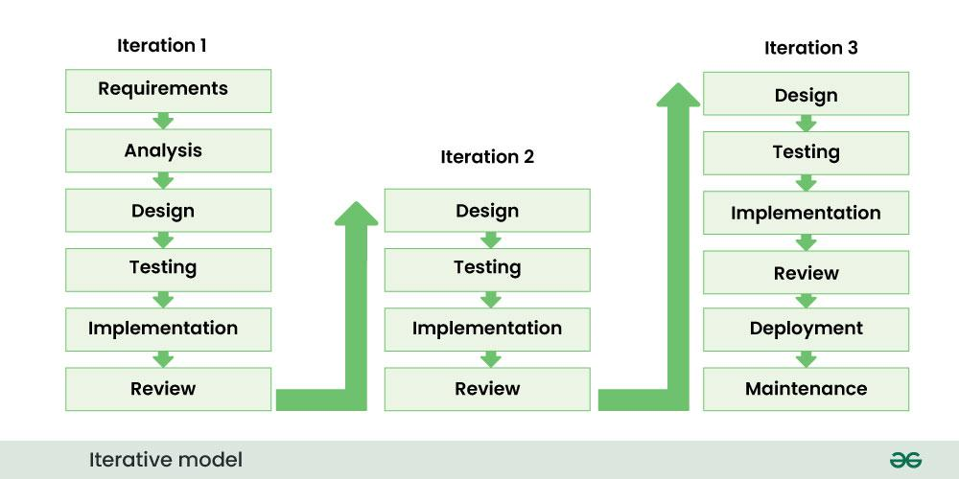

**7. Spiral Model**

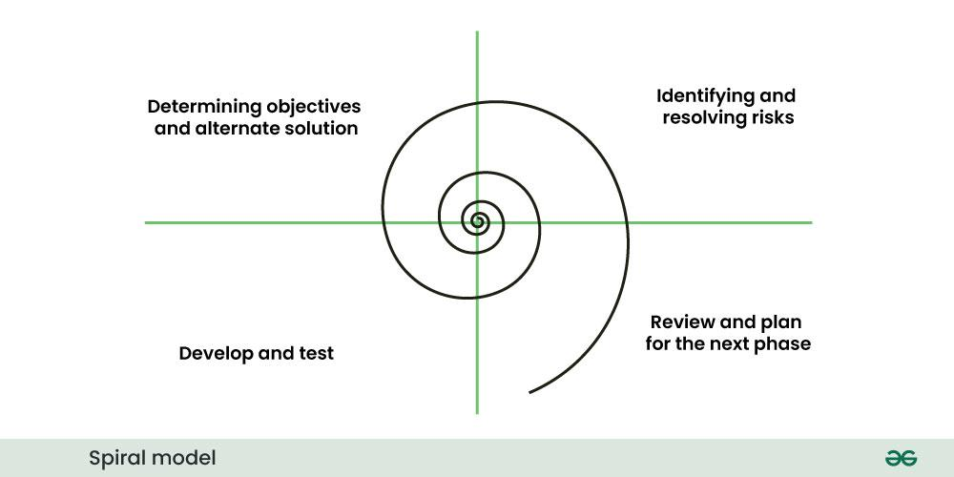[**Spiral Model**](https://www.geeksforgeeks.org/software-engineering-spiral-model/) is a software development process model. This model has characteristics of both iterative and waterfall models. This model is used in projects which are large and complex. This model was named spiral because if we look at its figure, it looks like a spiral, in which a long curved line starts from the center point and makes many loops around it. The number of loops in the spiral is not decided in advance but it depends on the size of the project and the changing requirements of the user. We also call each loop of the spiral a phase of the software development process.

**8. Prototype model**

[Prototype Model](https://www.geeksforgeeks.org/software-engineering-prototyping-model/) is an activity in which prototypes of software applications are created. First a prototype is created and then the final product is manufactured based on that prototype.

One problem in this model is that if the end users are not satisfied with the prototype model, then a new prototype model is created again, due to which this model consumes a lot of money and time.

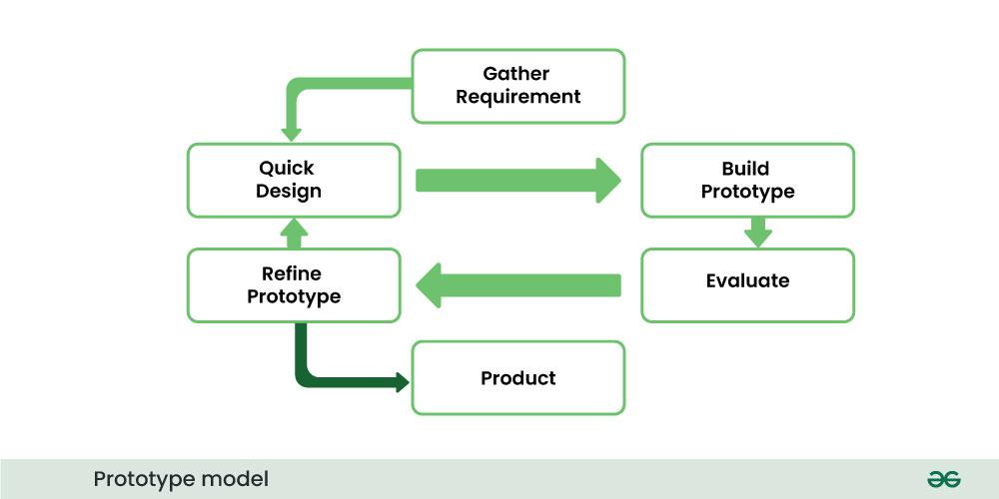

1. **Write a short note on Software Process Models and their comparison.**

**Software Process Models** are structured approaches used in software engineering to plan, design, develop, test, and maintain software systems. They provide a framework for managing software development and help ensure the final product meets requirements, stays within budget, and is delivered on time. Each model has its own strengths and is suitable for different types of projects.

**Common Software Process Models:**

1. **Waterfall Model**
   * Linear and sequential approach.
   * Phases: Requirements → Design → Implementation → Testing → Deployment → Maintenance.
   * Suitable for projects with well-defined requirements.
2. **V-Model (Validation and Verification Model)**
   * Extension of the Waterfall model with testing activities planned in parallel with development.
   * Emphasizes validation and verification.
3. **Incremental Model**
   * Develops the system in small parts (increments).
   * Each increment adds functional capability.
   * Allows partial implementation and early feedback.
4. **Spiral Model**
   * Combines iterative development with risk analysis.
   * Emphasizes risk management and prototyping.
   * Suitable for large, high-risk projects.
5. **Agile Model**
   * Iterative and incremental model emphasizing flexibility and customer feedback.
   * Promotes adaptive planning, evolutionary development, and early delivery.
   * Examples: Scrum, Kanban.

**Comparison of Software Process Models:**

|  |  |  |  |  |  |
| --- | --- | --- | --- | --- | --- |
| **Feature** | **Waterfall** | **V-Model** | **Incremental** | **Spiral** | **Agile** |
| Flexibility | Low | Low | Medium | High | Very High |
| Risk Management | Poor | Poor | Moderate | Strong | Adaptive |
| Customer Involvement | Low | Low | Medium | High | Very High |
| Time to Market | Long | Long | Faster | Depends | Very Fast |
| Suitable For | Simple projects | Critical systems | Medium-sized apps | Complex projects | Dynamic requirements |

* + **Explain the advantages and disadvantages of the Waterfall Model.**

1. **What is the Spiral Model? Where is it best suited?**

The Spiral Model is a [**Software Development Life Cycle (SDLC)**](https://www.geeksforgeeks.org/software-development-life-cycle-sdlc/) model that provides a systematic and iterative approach to software development. In its diagrammatic representation, looks like a spiral with many loops. The exact number of loops of the spiral is unknown and can vary from project to project. Each loop of the spiral is called a **phase**of the software development process.

Some **Key Points** regarding the **Stages of a Spiral Model**:

1. The exact number of phases needed to develop the product can be varied by the project manager depending upon the project risks.
2. As the project manager dynamically determines the number of phases, the project manager has an important role in developing a product using the spiral model.
3. It is based on the idea of a spiral, with each iteration of the spiral representing a complete software development cycle, from requirements gathering and analysis to design, implementation, testing, and maintenance.

**Phases of the Spiral Model**

The Spiral Model is a risk-driven model, meaning that the focus is on managing risk through multiple iterations of the software development process. **Each phase of the Spiral Model is divided into four Quadrants:**

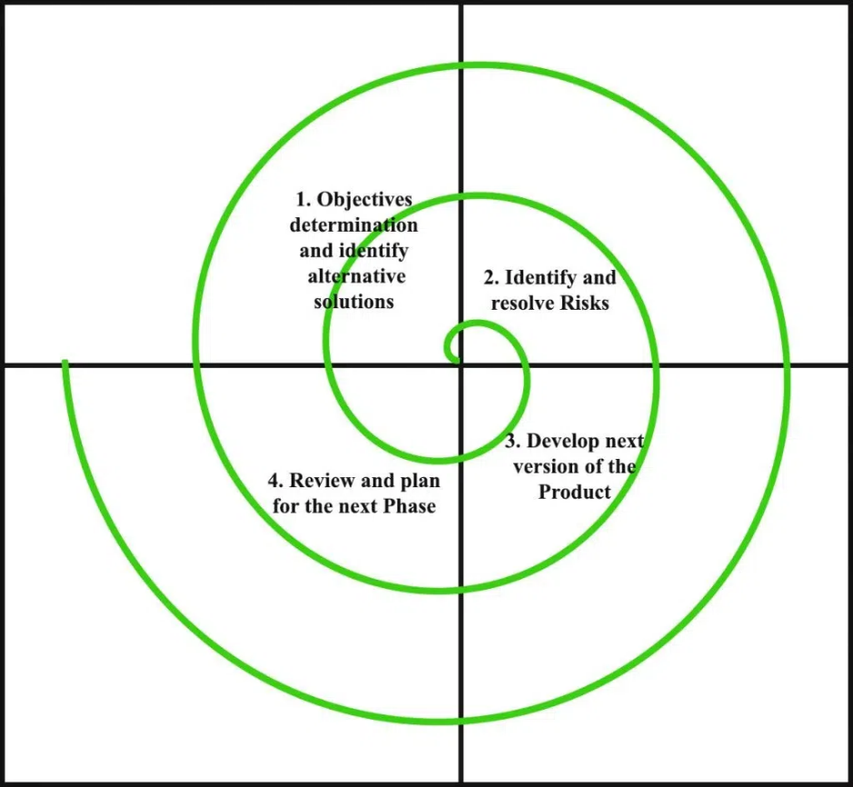

**1. Objectives Defined**

In first phase of the spiral model we clarify what the project aims to achieve, including functional and non-functional requirements.

Requirements are gathered from the customers and the objectives are identified, elaborated, and analyzed at the start of every phase. Then alternative solutions possible for the phase are proposed in this quadrant.

**2. Risk Analysis and Resolving**

In the risk analysis phase, the risks associated with the project are identified and evaluated.

During the second quadrant, all the possible solutions are evaluated to select the best possible solution. Then the risks associated with that solution are identified and the risks are resolved using the best possible strategy. At the end of this quadrant, the Prototype is built for the best possible solution.

**3. Develop the next version of the Product**

During the third quadrant, the identified features are developed and verified through testing. At the end of the third quadrant, the next version of the software is available.

In the evaluation phase, the software is evaluated to determine if it meets the customer’s requirements and if it is of high quality.

**4. Review and plan for the next Phase**

In the fourth quadrant, the Customers evaluate the so-far developed version of the software. In the end, planning for the next phase is started.

The next iteration of the spiral begins with a new planning phase, based on the results of the evaluation.

The Spiral Model is often used for complex and large software development projects, as it allows for a more flexible and adaptable approach to [**Software development**](https://www.geeksforgeeks.org/software-development/?ref=lbp). It is also well-suited to projects with significant uncertainty or high levels of risk.

**When To Use the Spiral Model?**

Here are the reasons where the **Spiral Model**is used:

1. When a project is vast in [**Software Engineering**,](https://www.geeksforgeeks.org/software-engineering-introduction-to-software-engineering/) a spiral model is utilized.
2. A spiral approach is utilized when frequent releases are necessary.
3. When it is appropriate to create a prototype
4. When evaluating risks and costs is crucial
5. The spiral approach is beneficial for projects with moderate to high risk.
6. The SDLC’s spiral model is helpful when requirements are complicated and ambiguous.
7. If modifications are possible at any moment
8. When committing to a long-term project is impractical owing to shifting economic priorities.

## MCQs:

* + **Which model is best suited for large, high-risk projects?**
  + **What does SRS stand for?**

# CO2: Demonstrate use of various Agile methodologies for software development

## Short/Long Questions:

1. **What is Agile Software Development? List its core values and principles.**

Agile Software Development is a [**Software Development Methodology**](https://www.geeksforgeeks.org/5-most-commonly-used-software-development-methodologies/)that values flexibility, collaboration, and customer satisfaction. It is based on the Agile Manifesto, a set of principles for software development that prioritize individuals and interactions, working software, customer collaboration, and responding to change.

**Agile Software Development Phases**

1. Requirements Gathering

2. Planning

3. Development

4. Testing

5. Deployment

6. Maintenance

**Agile Software Development Cycle**

Let’s see a brief overview of how development occurs in Agile philosophy.

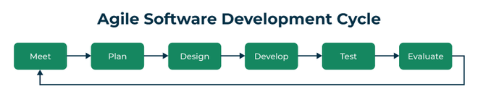

*Agile software development cycle*

* **Step 1:**In the first step, concept, and business opportunities in each possible project are identified and the amount of time and work needed to complete the project is estimated. Based on their technical and financial viability, projects can then be prioritized and determined which ones are worthwhile pursuing.
* **Step 2:**In the second phase, known as inception, the customer is consulted regarding the initial requirements, team members are selected, and funding is secured. Additionally, a schedule outlining each team’s responsibilities and the precise time at which each sprint’s work is expected to be finished should be developed.
* **Step 3:** Teams begin building functional software in the third step, iteration/construction, based on requirements and ongoing feedback. Iterations, also known as single development cycles, are the foundation of the Agile software development cycle.

**4 Core Values of Agile Software Development**

1. Individuals and Interactions over Processes and Tools
2. Working Software over Comprehensive Documentation
3. Customer Collaboration over Contract Negotiation
4. Responding to Change over Following a Plan

**12 Principles of Agile Software Development**

1. Ensuring customer satisfaction through the early delivery of software.
2. Being open to changing requirements in the stages of the development.
3. Frequently delivering working software with a main focus on preference for timeframes.
4. Promoting collaboration between business stakeholders and developers as an element.
5. Structuring the projects around individuals. Providing them with the necessary environment and support.
6. Prioritizing face to face communication whenever needed.
7. Considering working software as the measure of the progress.
8. Fostering development by allowing teams to maintain a pace indefinitely.
9. Placing attention on excellence and good design practices.
10. Recognizing the simplicity as crucial factor aiming to maximize productivity by minimizing the work.
11. Encouraging self organizing teams as the approach to design and build systems.
12. Regularly reflecting on how to enhance effectiveness and to make adjustments accordingly.
13. **Explain Extreme Programming (XP) with its key features.**

**What is Extreme Programming (XP)?**

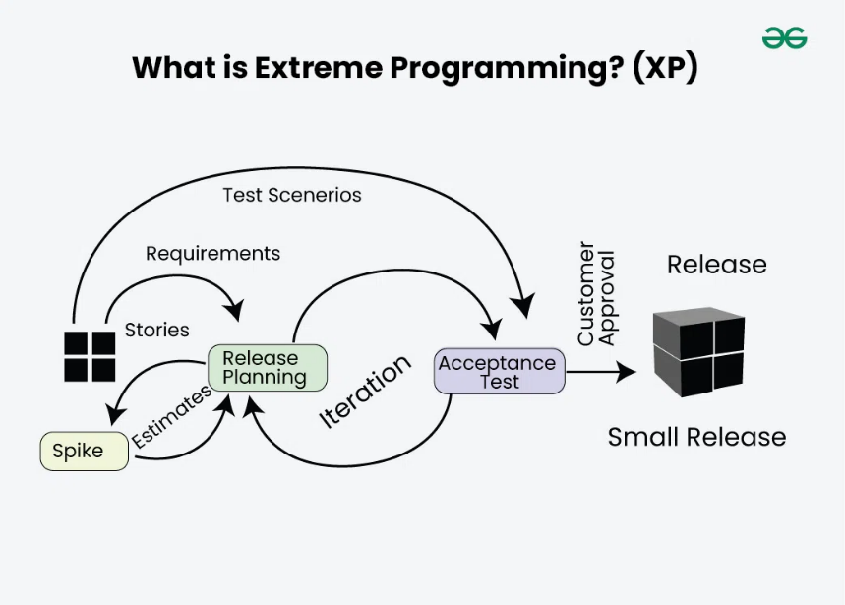Extreme Programming (XP) is an [Agile software development](https://www.geeksforgeeks.org/software-engineering-agile-software-development/) methodology that focuses on delivering high-quality software through frequent and continuous feedback, collaboration, and adaptation. XP emphasizes a close working relationship between the development team, the customer, and stakeholders, with an emphasis on rapid, iterative development and deployment.

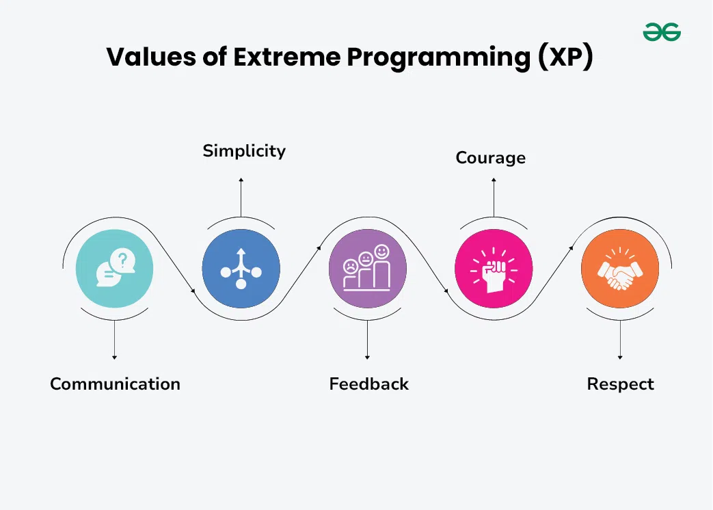**Featuures of Extreme Programming (XP)**

**There are features of Extreme Programming (XP)**

1. **Communication:**The essence of communication is for information and ideas to be exchanged amongst development team members so that everyone has an understanding of the system requirements and goals. Extreme Programming (XP) supports this by allowing open and frequent communication between members of a team.
2. **Simplicity:**Keeping things as simple as possible helps reduce complexity and makes it easier to understand and maintain the code.
3. **Feedback:**Feedback loops which are constant are among testing as well as customer involvements which helps in detecting problems earlier during development.
4. **Courage:**Team members are encouraged to take risks, speak up about problems, and adapt to change without fear of repercussions.
5. **Respect**: Every member’s input or opinion is appreciated which promotes a collective way of working among people who are supportive within a certain group.
6. **What is Scrum? Explain its high-level process.**

**What is a scrum in software development?**

Scrum is a management framework that teams use to self-organize tasks and work towards a common goal. It is a framework within which people can address complex adaptive problems while the productivity and creativity of delivering products are at the highest possible value. Scrum is a management framework that teams use to self-organize and work towards a common goal.

* Scrum allows us to develop products of the highest value while making sure that we maintain creativity and productivity.
* The iterative and incremental approach used in scrum allows the teams to adapt to the changing requirements.

**Silent features of Scrum**

* Scrum is a light-weighted framework
* Scrum emphasizes self-organization
* Scrum is simple to understand
* Scrum framework helps the team to work together
* Lifecycle of Scrum

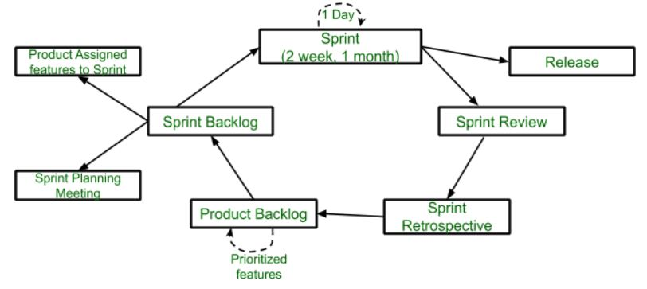

* [**Sprint**](https://www.geeksforgeeks.org/what-is-a-sprint-in-agile/)**:** A Sprint is a time box of one month or less. A new Sprint starts immediately after the completion of the previous Sprint. **Release:** When the product is completed, it goes to the Release stage.
* [**Sprint Review**](https://www.geeksforgeeks.org/sprint-review-meeting-purpose-importance-and-best-practice-in-software-development/)**:** If the product still has some non-achievable features, it will be checked in this stage and then passed to the Sprint Retrospective stage.
* [**Sprint Retrospective**](https://www.geeksforgeeks.org/sprint-retrospective-meeting-purpose-and-steps/)**:** In this stage quality or status of the product is checked. **Product Backlog:** According to the prioritize features the product is organized.
* [**Sprint Backlog**](https://www.geeksforgeeks.org/product-backlog-and-sprint-backlog-in-software-engineering/)**:** Sprint Backlog is divided into two parts Product assigned features to sprint and Sprint planning meeting.

1. **Describe Test-First Development with an example.**

**Test-First Development (TFD)** is a software development approach where **tests are written before the actual code**. It is a core practice of **Test-Driven Development (TDD)** and is used to ensure that the software meets the desired requirements from the start.

**✅ Key Steps in Test-First Development**

1. **Write a Test**
   * Create a test for the functionality you are about to implement.
   * The test should initially **fail** since the functionality doesn't exist yet.
2. **Run the Test**
   * Confirm that the test fails. This validates the test's correctness.
3. **Write the Minimum Code**
   * Write just enough code to make the test pass.
4. **Run the Test Again**
   * Verify that the test now passes.
5. **Refactor**
   * Clean up the code while ensuring that tests still pass.

**🧪 Example: Add Function in Python**

**Requirement:** Implement a function add(a, b) that returns the sum of two numbers.

**🔹 Step 1: Write the test first (before implementation)**

#include <gtest/gtest.h>

// Declaration of the function to be tested

int add(int a, int b);

// Test Case

TEST(MathTests, AddTest) {

EXPECT_EQ(add(2, 3), 5);

EXPECT_EQ(add(-1, 1), 0);

EXPECT_EQ(add(0, 0), 0);

}

**🔹 Step 2: Run the test**

* It fails: NameError: name 'add' is not defined

**🔹 Step 3: Write the minimum code to pass the test**

int add(int a, int b) {

return a + b;

}

**🔹 Step 4: Run the test again**

* The test now **passes** ✅

**🔹 Step 5: Refactor (if needed)**

* Code is already clean, so no change needed.

**🎯 Benefits of Test-First Development**

* Encourages clear understanding of requirements
* Leads to better design and code structure
* Reduces bugs and rework
* Improves confidence in code changes

1. **Differentiate between traditional SDLC and Agile.**

**Traditional SDLC vs. Agile**

|  |  |  |
| --- | --- | --- |
| **Aspect** | **Traditional SDLC (Waterfall)** | **Agile Methodology** |
| **Approach** | Linear and sequential | Iterative and incremental |
| **Flexibility** | Rigid — changes are hard to incorporate mid-process | Highly flexible — changes are welcome anytime |
| **Customer Involvement** | Minimal after requirement phase | Continuous involvement throughout development |
| **Development Phases** | Phases (like requirement, design, development, testing) are distinct and done one after another | All phases occur simultaneously in each iteration (sprint) |
| **Testing** | Done after coding is complete | Continuous testing in each iteration |
| **Delivery** | One final product at the end of the cycle | Frequent, working software delivered in short cycles |
| **Documentation** | Heavy documentation required | Minimal documentation — focus on working software |
| **Risk Handling** | High risk — issues may arise late | Early risk detection due to frequent iterations |
| **Best Suited For** | Projects with fixed, well-defined requirements | Projects with dynamic or evolving requirements |

## MCQs:

* + **Which of the following is not a principle of XP?**
  + **Agile development focuses on which of the following? (a) Documentation (b) Code Quality (c) Contracts (d) Rigid planning**

# CO3: Apply various modelling techniques for designing system requirements

## Short/Long Questions:

1. **What is UML? Explain different types of UML diagrams.**

**What is UML?**

Unified Modeling Language (UML) is a standardized visual modeling language that is a versatile, flexible, and user-friendly method for visualizing a system’s design. Software system artifacts can be specified, visualized, built, and documented with the use of UML.

* We use UML diagrams to show thebehavior and structure of a system.
* UML helps software engineers, businessmen, and system architects with modeling, design, and analysis.

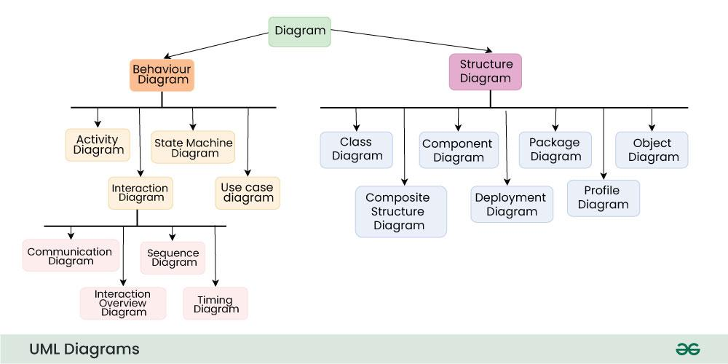**Types of UML Diagrams**

[Structural UML Diagrams](https://www.geeksforgeeks.org/structural-diagrams-unified-modeling-languageuml)

**1.**[**Class Diagram**](https://www.geeksforgeeks.org/unified-modeling-language-uml-class-diagrams)

The most widely use UML diagram is the class diagram. It is the building block of all object oriented software systems. We use class diagrams to depict the static structure of a system by showing system’s classes, their methods and attributes.

**2. Composite Structure Diagram**

We use composite structure diagrams to represent the internal structure of a class and its interaction points with other parts of the system.

**3.**[**Object Diagram**](https://www.geeksforgeeks.org/unified-modeling-language-uml-object-diagrams)

An Object Diagram can be referred to as a screenshot of the instances in a system and the relationship that exists between them.

**4.**[**Component Diagram**](https://www.geeksforgeeks.org/component-based-diagram/)

Component diagrams are used to represent how the physical components in a system have been organized.

**5.**[**Deployment Diagram**](https://www.geeksforgeeks.org/deployment-diagram-unified-modeling-languageuml)

Deployment Diagrams are used to represent system hardware and its software. It tells us what hardware components exist and what software components run on them.

**6.**[**Package Diagram**](https://www.geeksforgeeks.org/package-diagram-introduction-elements-use-cases-and-benefits)

We use Package Diagrams to depict how packages and their elements have been organized. A package diagram simply shows us the dependencies between different packages and internal composition of packages.

[Behavioral UML Diagrams](https://www.geeksforgeeks.org/behavior-diagrams-unified-modeling-languageuml)

**1.**[**State Machine Diagrams**](https://www.geeksforgeeks.org/unified-modeling-language-uml-state-diagrams)

A state diagram is used to represent the condition of the system or part of the system at finite instances of time. It’s a behavioral diagram and it represents the behavior using finite state transitions.

**2.**[**Activity Diagrams**](https://www.geeksforgeeks.org/unified-modeling-language-uml-activity-diagrams)

We use Activity Diagrams to illustrate the flow of control in a system. We can also use an activity diagram to refer to the steps involved in the execution of a use case.

**3.**[**Use Case Diagrams**](https://www.geeksforgeeks.org/use-case-diagram)

Use Case Diagrams are used to depict the functionality of a system or a part of a system. They are widely used to illustrate the functional requirements of the system and its interaction with external agents(actors).

**4.**[**Sequence Diagram**](https://www.geeksforgeeks.org/unified-modeling-language-uml-sequence-diagrams)

A sequence diagram simply depicts interaction between objects in a sequential order i.e. the order in which these interactions take place.

**5. Communication Diagram**

A Communication Diagram (known as Collaboration Diagram in UML 1.x) is used to show sequenced messages exchanged between objects.

**6. Timing Diagram**

Timing Diagram are a special form of Sequence diagrams which are used to depict the behavior of objects over a time frame. We use them to show time and duration constraints which govern changes in states and behavior of objects.

**7.**[**Interaction Overview Diagram**](https://www.geeksforgeeks.org/interaction-overview-diagrams-unified-modeling-language-uml)

An Interaction Overview Diagram (IOD) is a type of UML (Unified Modeling Language) diagram that illustrates the flow of interactions between various elements in a system or process. It provides a high-level overview of how interactions occur, including the sequence of actions, decisions, and interactions between different components or objects.

1. **Draw and explain a Use Case Diagram for a Library Management System.**
2. **Explain Class Diagram with notations and example.**

**UML Class Notation**

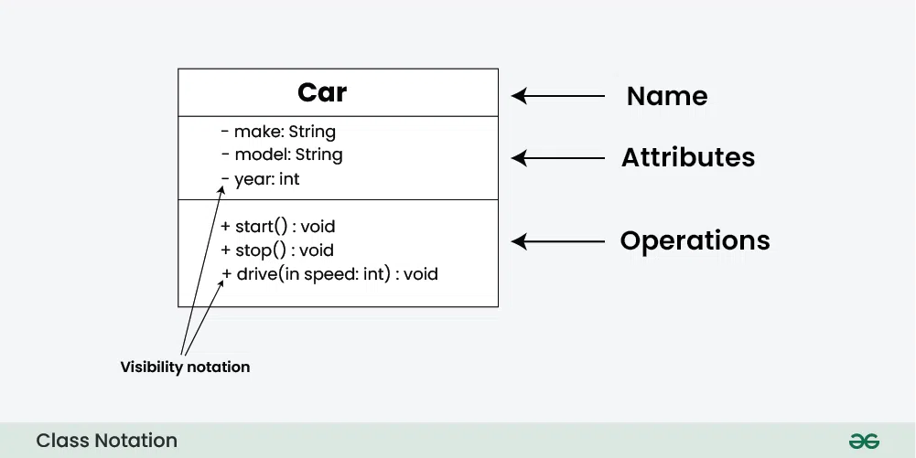class notation is a graphical representation used to depict classes and their relationships in object-oriented modeling.

1. **Class Name:**
   * The name of the class is typically written in the top compartment of the class box and is centered and bold.
2. **Attributes:**
   * Attributes, also known as properties or fields, represent the data members of the class. They are listed in the second compartment of the class box and often include the visibility (e.g., public, private) and the data type of each attribute.
3. **Methods:**
   * Methods, also known as functions or operations, represent the behavior or functionality of the class. They are listed in the third compartment of the class box and include the visibility (e.g., public, private), return type, and parameters of each method.
4. **Visibility Notation:**
   * Visibility notations indicate the access level of attributes and methods. Common visibility notations include:
     + + for public (visible to all classes)
     + - for private (visible only within the class)
     + # for protected (visible to subclasses)
     + ~ for package or default visibility (visible to classes in the same package)

**Parameter Directionality**

In class diagrams, parameter directionality refers to the indication of the flow of information between classes through method parameters. It helps to specify whether a parameter is an input, an output, or both. This information is crucial for understanding how data is passed between objects during method calls.

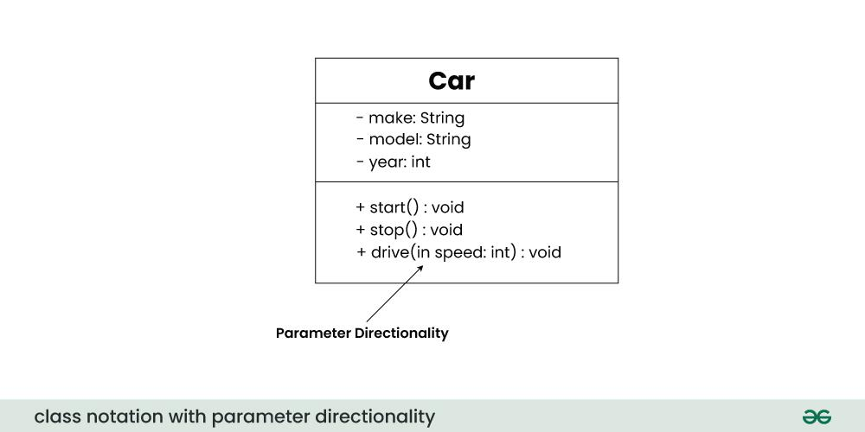

There are three main parameter directionality notations used in class diagrams:

* **In (Input):**
  + An input parameter is a parameter passed from the calling object (client) to the called object (server) during a method invocation.
  + It is represented by an arrow pointing towards the receiving class (the class that owns the method).
* **Out (Output):**
  + An output parameter is a parameter passed from the called object (server) back to the calling object (client) after the method execution.
  + It is represented by an arrow pointing away from the receiving class.
* **InOut (Input and Output):**
  + An InOut parameter serves as both input and output. It carries information from the calling object to the called object and vice versa.
  + It is represented by an arrow pointing towards and away from the receiving class.

1. **Differentiate between Structural and Behavioral UML diagrams.**

|  |  |  |
| --- | --- | --- |
| **Aspect** | **Structural UML Diagrams** | **Behavioral UML Diagrams** |
| **Purpose** | Describe the **static** aspects of a system | Describe the **dynamic** behavior of the system |
| **Focus** | System architecture, components, and relationships | System interactions, workflows, and object behavior over time |
| **Represents** | Classes, objects, components, and relationships | Processes, use cases, sequences, state changes |
| **Examples** | - Class Diagram - Object Diagram - Component Diagram - Deployment Diagram - Package Diagram | - Use Case Diagram - Sequence Diagram - Activity Diagram - State Machine Diagram - Communication Diagram |
| **Time Factor** | Time-independent (does not show changes over time) | Time-dependent (shows flow or change over time) |
| **Used For** | Designing and understanding system structure | Modeling interactions, workflows, and system behavior |

1. **Explain the concept of State Transition Diagram with an example.**

A S**tate diagram** is a UML diagram which is used to represent the condition of the system or part of the system at finite instances of time. It’s a behavioral diagram and it represents the behavior using finite state transitions.

* State Machine diagrams are also known as **State Diagrams**and **State-Chart Diagrams**. These both terms can be used interchangeably.
* A state machine diagram is used to model the dynamic behaviour of a class in response to time and changing external stimuli( events that cause the system to change its state from one to another).
* We can say that every class has a state but we don’t model every class using State Machine diagrams.

Let’s understand the State Machine Diagram with the help **user verification** example:

**Example:**

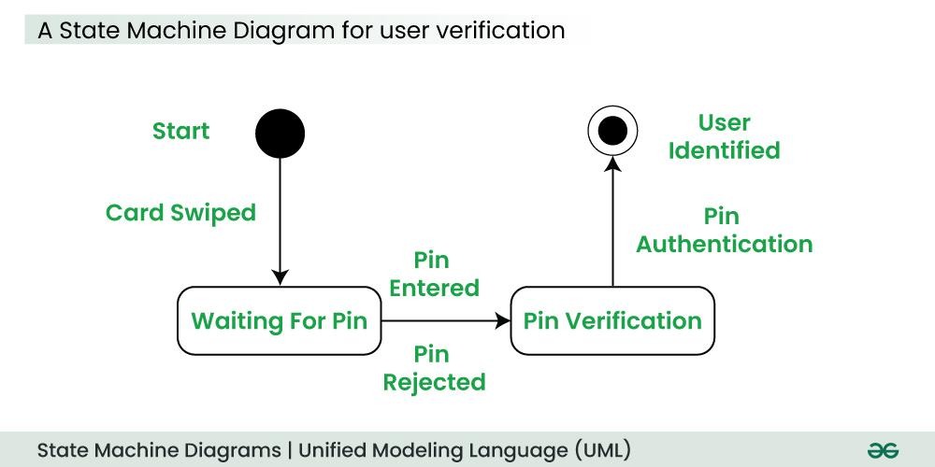

## The State Machine Diagram above shows the different states in which the verification sub-system or class exists for a particular system.

## MCQs:

* + **Which of these is a structural UML diagram?**
  + **Use case diagrams are mainly used for?**

# CO4: Identify different types of risk and evaluate its impact on software system

## Short/Long Questions:

1. **What is software risk? Explain different types of software risks.**

### What is Software Risk?

**Software risk** refers to the potential for an undesired outcome or failure in a software project. It is the possibility that a project might not achieve its intended goals in terms of **cost, schedule, quality, or functionality**. Risks are uncertain events that can have negative impacts on the success of the project if they occur.

**Types of Software Risks**

Software risks can be broadly classified into the following categories:

**1. Project Risks**

These affect the **project schedule or resources** and can delay delivery.

* **Examples:**
  + Unrealistic deadlines
  + Budget constraints
  + Inadequate planning or resource allocation
  + Poor communication among team members

**2. Technical Risks**

These relate to the **technology and software development process**.

* **Examples:**
  + Use of new or untested technologies
  + Integration issues with existing systems
  + Inadequate design or architecture
  + Performance or scalability limitations

**3. Product Risks**

These impact the **quality or functionality** of the final product.

* **Examples:**
  + Misunderstanding customer requirements
  + Incomplete or incorrect specifications
  + Defects or bugs in the software
  + Lack of usability or poor user interface

**4. Business Risks**

These affect the **business or financial outcomes** of the project.

* **Examples:**
  + Change in market demand or user preferences
  + Loss of stakeholder support
  + Poor return on investment (ROI)
  + Regulatory or legal issues

**5. Security Risks**

These relate to the **confidentiality, integrity, and availability** of data.

* **Examples:**
  + Unauthorized access to sensitive data
  + Data breaches or cyberattacks
  + Insufficient encryption or authentication mechanisms

1. **How do you perform risk analysis during software development?**

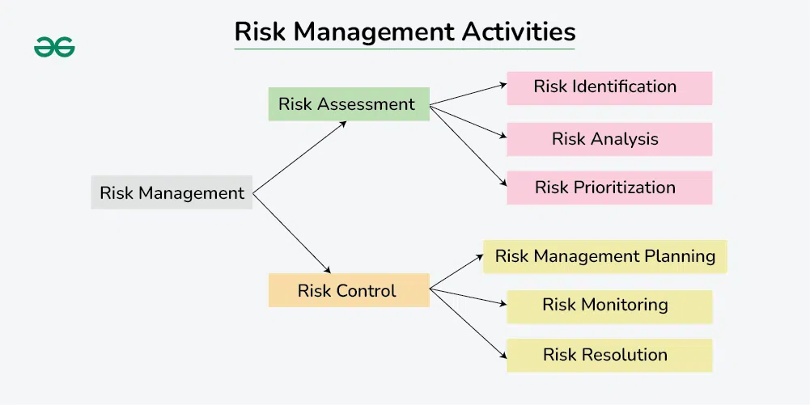In order to conduct risk analysis in software development, first you have to evaluate the source code in detail to understand its component. This evaluation is done to address components of code and map their interactions. With the help of the map, transaction can be detected and assessed. The map is subjected to structural and architectural guidelines in order to recognize and understand the primary software defects. Following are the steps to perform software risk analysis.

**Risk Assessment**

The purpose of the risk assessment is to identify and priorities the risks at the earliest stage and avoid losing time and money.  
Under risk assessment, you will go through:

* **Risk identification:** It is crucial to detect the type of risk as early as possible and address them. The risk types are classified into
  + People risks: related to the people in the software development team
  + Tools risks: related to using tools and other software
  + Estimation risks: related to estimates of the resources required to build the software
  + Technology risks: are related to the usage of hardware or software technologies required to build the software
  + Organizational risks: are related to the organizational environment where the software is being created.
* **Risk analysis:** Experienced developers analyze the identified risk based on their experience gained from previous software . In the next phase, the Software Development team estimates the probability of the risk occurring and its seriousness
* **Risk prioritization:** The risk priority can be identified using the formula below

p = r * s

**Where,**

p stands for priority

r stands for the probability of the risk becoming true or false

s stands for the severity of the risk.

**Risk control**

Risk control is performed to manage the risks and obtain desired results. Once identified, the risks can be classified into the most and least harmful.

Under risk control, you will go through:

* **Risk management planning:** You can leverage three main strategies to plan risk management.
  + Reduce the risk: This method involves planning to reduce the loss caused by the risk. For instance, planning to hire new employees to replace employees serving notice.
  + Transfer the risk: This method involves buying insurance or hiring a third-party organization to solve a challenging problem that might pose harmful risks
  + Avoid the risk: This method involves implementing various strategies, such as incentivizing underpaid, hardworking engineers who might quit the organization
* **Risk monitoring:**It includes tracking and evaluating different levels of risk in the software development team. After completing the risk monitoring process, the findings can be utilized to devise new strategies to update ineffective methods
* **Risk resolution:** It involves eliminating the overall risk or finding solutions. This method includes techniques such as design to cost approach, simulating the prototype, benchmarking, etc.

1. **What are the strategies to manage risk in a software project?**

**Strategies to Manage Risk in a Software Project**

Effective **risk management** involves identifying, analyzing, and taking action to reduce or eliminate the impact of risks throughout the software development lifecycle.

Here are the **main strategies** used to manage risks in software projects:

**1. Risk Avoidance**

* **Objective:** Eliminate the risk entirely.
* **How:** Change the project plan or scope to remove the source of risk.

**Example:**  
Avoid using an unfamiliar technology stack by choosing a well-established one.

**2. Risk Reduction (Mitigation)**

* **Objective:** Minimize the probability or impact of the risk.
* **How:** Take proactive steps to lessen risk effects.

**Example:**  
Provide training to developers when adopting a new technology to reduce technical risk.

**3. Risk Transfer**

* **Objective:** Shift the risk to a third party.
* **How:** Use contracts, outsourcing, or insurance.

**Example:**  
Outsource a risky module to a vendor with expertise in that domain.

**4. Risk Acceptance**

* **Objective:** Acknowledge the risk without taking immediate action.
* **How:** Monitor it and plan for possible impact if it occurs.

**Example:**  
Accept the risk of minor UI changes late in the project as low-priority.

**5. Risk Sharing**

* **Objective:** Distribute the impact or ownership of the risk across stakeholders or teams.
* **How:** Collaborate with partners or clients to jointly manage the risk.

**Example:**  
Share the responsibility for unclear requirements with the client through regular feedback sessions.

**6. Contingency Planning**

* **Objective:** Prepare a **backup plan** (Plan B) in case the risk materializes.
* **How:** Create action plans and allocate resources to handle risk events.

**Example:**  
If a key developer leaves, a backup resource and documentation plan are in place.

1. **Explain the relationship between risk and software quality.**

**Relationship Between Risk and Software Quality**

**Risk** and **software quality** are closely connected in software development. Managing risks effectively leads to higher quality software, while ignoring risks can directly **reduce product quality**.

**Key Relationships:**

**1. Risks Impact Software Quality Attributes**

Poorly managed risks can negatively affect:

* **Reliability**: If risks like unhandled exceptions or memory leaks are not mitigated.
* **Performance**: Risk of choosing the wrong architecture can lead to slow or laggy software.
* **Security**: Ignoring risk in authentication or data protection leads to vulnerabilities.
* **Usability**: Misinterpreting user needs due to unclear requirements is a common risk.

**2. Uncontrolled Risks Lead to Defects**

* Risks like changing requirements, lack of testing, or poor communication often introduce **bugs, errors, and inconsistencies** into the system, lowering quality.

**3. Risk Management Improves Quality**

* Identifying and mitigating risks early (e.g., with better test coverage or user involvement) **prevents issues before they occur**, leading to a more stable and polished product.

**4. Quality Assurance Helps Identify Risks**

* QA activities such as code reviews, testing, and audits can **reveal hidden risks** and areas of weakness in the system.

**5. Trade-off Between Risk and Quality**

* Sometimes, to meet deadlines or budget, teams may accept certain risks (e.g., reduced testing), which compromises software quality.

1. **Describe risk mitigation, monitoring, and management (RMMM) plan.**

**Risk Mitigation, Monitoring, and Management (RMMM) Plan**

An **RMMM Plan** is a structured approach used in software project management to systematically handle risks throughout the software development lifecycle. It ensures that risks are **identified, analyzed, addressed, tracked, and controlled** effectively.

**1. Risk Mitigation**

**Definition:**  
Risk mitigation involves taking **proactive steps to reduce the probability and/or impact** of a risk before it occurs.

**Mitigation Strategies:**

* Use proven technology instead of experimental tools.
* Train team members in required skills.
* Allocate additional resources for critical tasks.
* Improve requirements clarity via early client involvement.

**Example:**  
To mitigate the risk of data loss, implement regular data backups and version control.

**2. Risk Monitoring**

**Definition:**  
Monitoring is the **continuous process of tracking identified risks**, watching for new risks, and ensuring mitigation actions are effective.

**Activities:**

* Review risk status in regular project meetings.
* Update risk registers.
* Identify triggers that indicate risk occurrence.
* Log new risks as they are discovered.

**Example:**  
Monitoring team morale to detect early signs of burnout, which may lead to productivity loss.

**3. Risk Management**

**Definition:**  
Risk management refers to the **overall process** of identifying, evaluating, planning for, and responding to risks across the project lifecycle.

**Components of Risk Management:**

* Risk Identification
* Risk Assessment (qualitative or quantitative)
* Risk Prioritization
* Risk Response Planning (mitigation, acceptance, etc.)
* Risk Tracking and Re-evaluation

**Goal:**  
Minimize the impact of risks on **cost, time, quality, and project success**.

## MCQs:

* + **Which of the following is a technical risk?**
  + **Risk management is performed during which phase of SDLC?**

# CO5: Distinguish different testing strategies and create test cases

## Short/Long Questions:

1. **Explain Black Box Testing with strategies like BVA and EP.**

**Black Box Testing**

**Black Box Testing** is a software testing technique where the **internal structure or code is not known** to the tester. The focus is purely on **inputs and expected outputs** to verify software functionality.

**Objective:**

To check whether the software behaves as expected under various input conditions, **without considering how the program is implemented internally**.

**Characteristics of Black Box Testing:**

* Tests functionality, not code.
* Based on **software requirements and specifications**.
* Typically performed by **testers** or QA teams, not developers.
* Used in **System Testing**, **Acceptance Testing**, and sometimes in **Integration Testing**.

**Common Black Box Testing Strategies:**

**1. Boundary Value Analysis (BVA)**

**Definition:**  
Tests the boundaries between partitions. Errors often occur at the **edges** of input ranges.

**Concept:**

* If valid input range is 10 to 100, test with:
  + **Below boundary**: 9
  + **On lower boundary**: 10
  + **Just above lower boundary**: 11
  + **Just below upper boundary**: 99
  + **On upper boundary**: 100
  + **Above boundary**: 101

**Why it's useful:**  
Many errors occur at **min/max limits** due to improper conditional logic.

**2. Equivalence Partitioning (EP)**

**Definition:**  
Divides input data into **valid and invalid partitions** where test cases from each partition are expected to behave similarly.

**Concept:**

* For input field that accepts age from 18 to 60:
  + Valid partition: 18–60
  + Invalid partitions: <18 and >60

Choose one value from each partition:

* Valid: 25
* Invalid: 17, 61

**Why it's useful:**  
Minimizes the number of test cases while maintaining **good coverage**.

1. **Explain White Box Testing with coverage criteria.**

**White Box Testing**

**White Box Testing** (also called **Clear Box**, **Structural**, or **Glass Box Testing**) is a software testing method where the **internal logic and structure of the code** is tested. Testers must have knowledge of the **codebase** and its **control flow**.

**Key Characteristics:**

* Focuses on **how** the software works, not just what it does.
* Conducted by **developers** or technically skilled testers.
* Useful for **unit testing**, **integration testing**, and sometimes **system testing**.
* Helps in identifying:
  + Logical errors
  + Looping issues
  + Boundary condition errors
  + Unreachable code

**Common White Box Testing Techniques:**

1. **Statement Coverage**
2. **Branch (Decision) Coverage**
3. **Condition Coverage**
4. **Path Coverage**
5. **Loop Coverage**

**1. Statement Coverage**

Ensures that **every statement** in the program is executed **at least once**.

**2. Branch (Decision) Coverage**

Ensures that **each decision (true/false branch)** is executed.

**3. Condition Coverage**

Checks **each individual condition** in a decision, even within complex expressions.

**4. Path Coverage**

Ensures that **all possible execution paths** are tested at least once.

**5. Loop Coverage**

Specifically tests **loop constructs**:

* Loop runs zero times
* Loop runs once
* Loop runs multiple times
* Loop runs to its maximum allowed iterations

1. **Differentiate between Alpha and Beta Testing.**

|  |  |  |
| --- | --- | --- |
| **Feature** | **Alpha Testing** | **Beta Testing** |
| **Stage** | Conducted at the **end of development** but before release | Conducted **after Alpha Testing**, before final release |
| **Location** | Done **in-house** at the developer's site | Done **at end-users’ site** or in a real environment |
| **Testers** | Performed by **internal employees/testers** | Performed by **real users/customers** |
| **Environment** | **Controlled environment** | **Real-world environment** |
| **Purpose** | To identify bugs before release | To get **user feedback** and uncover hidden issues |
| **Focus** | Functionality, usability, and reliability | User experience, usability, and unexpected issues |
| **Duration** | Short and limited | Longer and more extensive |
| **Bug Reporting** | Bugs are logged and fixed **immediately** | Bugs are reported by users for **future fixes** |
| **Access** | Not open to public | Can be open to public or selected users |
| **Example** | Microsoft runs Alpha tests in-house before releasing Windows | Google releases Beta versions of apps on Play Store |

1. **Explain Regression Testing with an example.**

**Regression Testing**

**Regression Testing** is a type of software testing performed to **ensure that recent changes or bug fixes haven't negatively affected the existing functionality** of the application.

**Key Objectives:**

* Verify that new code changes don’t introduce new bugs.
* Ensure that **old features still work as expected** after enhancements, patches, or configuration changes.
* Maintain **software stability** throughout the development lifecycle.

**When to Perform Regression Testing:**

* After fixing bugs or defects.
* After new functionality is added.
* After performance or security improvements.
* During code refactoring or migration.

**Example:**

Imagine you are working on an **e-commerce website** with a **“Login”** and **“Add to Cart”** feature.

**Scenario:**

* You fix a bug in the **Login** module.
* After the fix, you perform regression testing to ensure:
  + The **Login** works correctly.
  + The **Add to Cart**, **Search**, and **Checkout** functionalities still work (i.e., were not broken by the change in the Login module).

**Techniques for Regression Testing:**

* **Retest All**: Run all test cases again (time-consuming).
* **Regression Test Selection**: Select a subset of relevant tests.
* **Test Case Prioritization**: Prioritize tests based on criticality and usage.
* **Automated Regression Testing**: Automate frequent regression test cases using tools like **Selenium**, **JUnit**, or **TestNG**.

**Benefits:**

* Prevents **reintroduction of old bugs**.
* Increases **confidence** in code stability.
* Supports **continuous integration and delivery**.

1. **Create test cases for a login page using equivalence class partitioning.**

**Test Case Design for a Login Page using Equivalence Class Partitioning (ECP)**

**Assumptions** for the login page:

* **Username** must be a valid email address.
* **Password** must be 6–12 characters long.
* Both fields are required (non-empty).

**Step 1: Identify Input Fields**

* **Username (email)**
* **Password**

**Step 2: Identify Equivalence Classes**

**For Username (Email):**

* **Valid Class**: Properly formatted email (e.g., user@example.com)
* **Invalid Class**:
  + Empty
  + Improper format (e.g., user@com, user.com, user@)

**For Password:**

* **Valid Class**: 6 to 12 characters (e.g., abc123, myp@sswd12)
* **Invalid Class**:
  + Less than 6 characters (e.g., abc12)
  + More than 12 characters (e.g., abcdefghijklmn)
  + Empty

**Step 3: Define Test Cases Based on These Classes**

|  |  |  |  |  |
| --- | --- | --- | --- | --- |
| **Test Case ID** | **Username** | **Password** | **Expected Result** | **Reason** |
| TC01 | [user@example.com](mailto:user@example.com) | abc123 | Login Successful | Both fields are valid |
| TC02 |  | abc123 | Error: Username required | Username is empty |
| TC03 | userexample.com | abc123 | Error: Invalid email format | Invalid email |
| TC04 | user@ | abc123 | Error: Invalid email format | Missing domain |
| TC05 | [user@example.com](mailto:user@example.com) |  | Error: Password required | Password is empty |
| TC06 | [user@example.com](mailto:user@example.com) | abc12 | Error: Password too short | Password < 6 characters |
| TC07 | [user@example.com](mailto:user@example.com) | abcdefghijklm | Error: Password too long | Password > 12 characters |
| TC08 |  |  | Error: All fields required | Both fields empty |

## MCQs:

* + **Which testing method does not require code knowledge?**
  + **What is the goal of system testing?**

# CO6: Able to understand and apply the basic project management practices in real-life projects

## Short/Long Questions:

1. **Explain the phases of the Unified Software Development Process.**

The **Unified Software Development Process** (also known as the **Unified Process** or **RUP** – Rational Unified Process) is an **iterative and incremental software development framework** that organizes development into **phases** with distinct goals and deliverables.

✅ **Phases of the Unified Software Development Process:**

|  |  |  |  |
| --- | --- | --- | --- |
| **Phase** | **Purpose** | **Key Activities** | **Major Deliverables** |
| 1. **Inception** | Define the **scope** and **business case** | - Identify stakeholders- Define high-level requirements- Estimate cost and time | - Vision document- Initial use-case model- Business case |
| 2. **Elaboration** | Analyze the problem domain and **design architecture** | - Refine requirements- Develop architecture- Identify risks | - Software architecture document- Updated use-case model- Prototype |
| 3. **Construction** | Build the **software system** incrementally | - Code development- Component integration- Unit and integration testing | - Working software- Test cases- Documentation |
| 4. **Transition** | Deliver software to **end-users** | - User training- Beta testing- Bug fixing- Deployment | - Final product release- User manuals- Deployment plan |

**🔁 Iterative Nature:**

Each phase may involve **multiple iterations**, allowing for feedback, testing, and adjustment throughout the lifecycle. The focus **shifts gradually** from requirements to development to deployment.

**🔑 Key Principles of Unified Process:**

* **Use-case driven**
* **Architecture-centric**
* **Iterative and incremental**
* **Risk-focused**

1. **What is software reengineering? When is it required?**

**✅ What is Software Reengineering?**

**Software Reengineering** is the process of **analyzing, modifying, and improving existing software** to enhance its functionality, maintainability, performance, or adaptability—**without changing its core functionality**.

It is essentially about **"renewing"** or **"rebuilding"** an existing system to extend its life and make it more efficient or compatible with modern environments.

**🛠 Key Activities in Software Reengineering:**

* **Reverse Engineering**: Understanding the existing code and design.
* **Code Restructuring**: Improving code quality, readability, and structure.
* **Data Restructuring**: Optimizing or redesigning data models.
* **Documentation Updating**: Creating or improving missing/outdated documentation.
* **Forward Engineering**: Rebuilding or refactoring parts of the system into a modern architecture or language.

**📌 When is Software Reengineering Required?**

|  |  |  |
| --- | --- | --- |
| **Situation** | **Explanation** | **Situation** |
| ⚙️ **Legacy systems** still in use | The software is old but still performs critical business functions. | ⚙️ **Legacy systems** still in use |
| 🐛 **Poor maintainability** | The system is difficult to understand, modify, or test. | 🐛 **Poor maintainability** |
| 📈 **Performance issues** | The software becomes slow or inefficient under current load. | 📈 **Performance issues** |
| 🔄 **Platform migration** | Moving software from old platforms (e.g., mainframe) to modern environments (e.g., cloud). | 🔄 **Platform migration** |
| 📚 **Lack of documentation** | When no documentation exists, reengineering helps create one through reverse engineering. | 📚 **Lack of documentation** |
| 👥 **Developer turnover** | New developers find it hard to understand the old codebase. | 👥 **Developer turnover** |
| 🔐 **Security vulnerabilities** | Outdated components expose the system to security threats. | 🔐 **Security vulnerabilities** |

**🎯 Benefits:**

* Improved **software quality** and **reliability**
* Easier **maintenance** and **upgrades**
* Better **performance** and **security**
* Extended **lifespan** of valuable systems

1. **Discuss the role of version control in project management.**

**Role of Version Control in Project Management**

Version control plays a **crucial role in project management**, especially in software development. It is the practice of **tracking and managing changes** to a project's codebase, documents, or any other project artifacts over time. Version control helps teams collaborate effectively, maintain control over their work, and keep the project on track.

**Key Roles of Version Control in Project Management:**

**1. Collaboration & Team Coordination**

* **Multiple Contributors**: Version control allows multiple team members to work on different parts of the project simultaneously, without interfering with each other’s work.
* **Merging Changes**: When different team members make changes, version control helps **merge their contributions** into a unified codebase, reducing conflicts and preventing issues caused by incompatible changes.

**2. Tracking Changes**

* **History of Changes**: Version control systems (VCS) maintain a full history of every change made to the project. This allows project managers and developers to review and understand what was changed, by whom, and why.
* **Accountability**: Each change is associated with the developer's identity and a description, making it easier to track **responsibility** for specific modifications.

**3. Code Quality and Stability**

* **Branching and Experimentation**: Developers can create **branches** to experiment or implement new features without affecting the main project. Once changes are stable, they can be merged back.
* **Rollback Capability**: If a change causes issues or bugs, version control allows teams to **roll back** to a previous stable version, ensuring that project quality is not compromised.

**4. Parallel Development**

* **Feature Branches**: Teams can create isolated branches to develop new features or bug fixes. Once features are complete and tested, they are integrated into the main branch, ensuring a smooth workflow without disrupting other work.
* **Release Management**: Version control supports managing different **versions** or **releases** of the software, helping teams plan and deliver software updates in a structured manner.

**5. Documentation & Traceability**

* **Documentation of Changes**: Changes to the project are logged with **commit messages**, providing insight into the rationale behind each update. This helps in understanding the project's evolution.
* **Auditability**: Version control systems often include features like **blame** (to identify who last modified a line of code), which helps in investigating and debugging issues effectively.

**6. Backup and Recovery**

* **Safe Storage**: All project files are stored in a version control repository, providing an **automated backup system**. In case of data loss or corruption, previous versions can be restored.
* **Disaster Recovery**: Having a versioned backup ensures that the team can recover lost work or fix mistakes without starting from scratch.

**7. Continuous Integration/Continuous Deployment (CI/CD)**

* **Automation**: Version control integrates with CI/CD tools to automate the testing, building, and deployment of software, ensuring faster and more reliable releases.
* **Consistency**: By using version control, teams ensure that the correct version of the code is deployed, reducing the chances of deploying unstable or incorrect versions.

**Benefits of Version Control in Project Management:**

1. **Enhanced Collaboration**: Developers can work in parallel without overriding each other’s work.
2. **Improved Project Visibility**: Managers can see what’s happening in the project, who’s working on what, and track progress.
3. **Error Management**: Version control helps prevent and manage errors, enabling easy rollbacks and providing insight into the cause of issues.
4. **Planning and Release Management**: Managers can plan releases based on versions and milestones, improving the predictability of delivery.
5. **Reduced Risk**: With the ability to trace changes, test features in isolation, and revert to stable versions, version control reduces the risk of introducing bugs into production.

**Common Version Control Systems (VCS):**

* **Git** (popular for distributed version control, e.g., GitHub, GitLab, Bitbucket)
* **Subversion (SVN)** (centralized version control)
* **Mercurial** (distributed version control)
* **Perforce** (centralized version control)

1. **Explain the significance of refactoring and when not to refactor.**

**Significance of Refactoring in Software Development**

**Refactoring** is the process of **modifying and improving the internal structure of existing code** without changing its external behavior. The primary goal of refactoring is to make the code **cleaner**, **easier to understand**, and **easier to maintain**, ultimately improving software quality.

Refactoring is a continuous process throughout the software development lifecycle. It helps manage complexity and keep the codebase healthy as the software evolves.

**Significance of Refactoring**

1. **Improves Code Quality**:
   * **Simplifies the codebase**: Refactoring helps eliminate **duplicate code**, reduces **complexity**, and makes the code easier to understand.
   * **Enhances readability**: Cleaner code is easier for developers to read, which means they can understand the system faster and make modifications with fewer risks of introducing errors.
   * **Reduces technical debt**: Over time, a project can accumulate "bad code" or poor design decisions. Refactoring helps remove this technical debt and improves the long-term maintainability of the software.
2. **Easier to Maintain**:
   * **Improved maintainability**: Well-structured and clean code is much easier to debug, extend, and modify. This helps the team respond to future requirements and fix issues more efficiently.
   * **Modularity**: Refactoring often encourages better design principles (e.g., breaking large functions into smaller ones), which allows teams to maintain and modify specific components without impacting others.
3. **Increased Performance** (Indirectly):
   * While refactoring is not primarily focused on improving performance, **better-structured code** can lead to **optimized algorithms** or the **removal of bottlenecks** that were previously hard to identify in complex code.
4. **Facilitates New Feature Development**:
   * As new features are added, **clean code** allows developers to add functionalities without introducing **side effects** or risking the integrity of existing functionality.
   * **Reduces the chance of regression**: By maintaining a clean and consistent code structure, the likelihood of unintentional side effects when adding new features is reduced.
5. **Improves Collaboration**:
   * **Standardized code** makes it easier for developers to collaborate on the same codebase. New team members can quickly understand and contribute to the project.

**When Not to Refactor**

While refactoring is beneficial, there are situations when **it may not be the right choice**:

1. **Lack of Time or Resources**:
   * Refactoring takes time, and in some cases, it might not provide immediate value (especially if you're working under tight deadlines). In this case, refactoring could delay the delivery of crucial features.
   * **Trade-offs**: Focus on features and functionality rather than on perfecting the code, especially when time or resource constraints exist.
2. **If the Codebase is Too Unstable**:
   * Refactoring requires a stable base to work with. If the software is in a **highly unstable state** with constant bugs, performance issues, or incomplete features, refactoring could make things worse.
   * **Fix critical issues first**: Before refactoring, it's important to ensure the software works correctly and is stable enough to change without introducing more risks.
3. **When There Is No Clear Benefit**:
   * Refactoring should only be done if it **adds value** in terms of making the code more maintainable, easier to understand, or better aligned with current goals.
   * If the changes are **cosmetic** and do not address long-term maintainability or performance issues, the effort might not be worth it.
4. **Lack of Proper Test Coverage**:
   * Refactoring can introduce new bugs if the system is not properly tested. Without a comprehensive set of **unit tests**, **integration tests**, and **system tests**, refactoring can inadvertently break existing functionality.
   * **Test coverage is critical**: Ensure that sufficient tests exist to verify that the refactored code does not change the system’s behavior.
5. **When the Codebase is About to Be Replaced**:
   * If the system is **being replaced** or is at the end of its lifecycle, refactoring may not be cost-effective. Instead, it may be better to focus on building a new, more efficient solution.
   * **Cost-benefit analysis**: If the software is being deprecated soon or if a complete redesign is planned, refactoring might not provide enough value to justify the effort.
6. **During Active Feature Development**:
   * If you are in the middle of adding new features and the deadline is near, refactoring might slow down the overall project. It’s better to refactor when the major functionality is stable and after features have been completed.

**Best Practices for Refactoring:**

* **Refactor in Small Steps**: Avoid large-scale changes. Make small, incremental improvements and test frequently to catch issues early.
* **Use Automated Tests**: Ensure there are unit tests and integration tests to verify that refactoring does not break functionality.
* **Prioritize High-Impact Areas**: Focus on areas of the codebase that have the biggest impact on maintainability or performance.
* **Refactor Regularly**: Make refactoring a regular part of the development process. Small improvements over time lead to a healthier codebase.

1. **What is software evolution? How do you manage legacy systems?**

**What is Software Evolution?**

**Software Evolution** refers to the **process of continuous development and improvement** of software over time to adapt to changing requirements, environments, and technologies. It involves the ongoing changes, enhancements, and updates to a software system to meet the evolving needs of users, stakeholders, and business goals.

In essence, software is rarely static. As user demands grow, technologies evolve, or issues are discovered, software systems undergo changes to keep them useful, relevant, and efficient.

**Phases of Software Evolution:**

1. **Initial Development**:
   * The first version of the software is developed and released. This version addresses the core requirements but may have limited features.
2. **Maintenance and Enhancements**:
   * As the software is used, new **features** are added, and **bugs** or **issues** are fixed. This is often the longest phase and is critical to the software’s longevity.
3. **Adapting to Changes**:
   * The software needs to **adapt** to new environments (e.g., OS updates, hardware changes, or new technologies). It could involve **porting** or **refactoring** to make it compatible with newer systems.
4. **Reengineering and Refactoring**:
   * Over time, the codebase may become hard to maintain due to **technical debt** or outdated design. **Reengineering** is performed to modernize the system and make it more maintainable, scalable, and adaptable to future changes.
5. **Retirement or Replacement**:
   * When the software reaches its end-of-life (EOL), it may be retired, replaced, or integrated into a newer system. The goal is to transition smoothly, ensuring minimal disruption to users and business operations.

**Key Drivers of Software Evolution:**

* **Changing Requirements**: Business needs and user demands evolve over time, requiring software to adapt.
* **Technological Advancements**: New technologies, tools, and platforms emerge, prompting the software to be upgraded or ported.
* **Regulatory and Compliance Changes**: Legal requirements (such as security regulations) may force updates to ensure compliance.
* **Bug Fixes and Performance Improvements**: As issues are identified, the system needs to evolve to fix bugs, improve performance, and enhance stability.
* **User Feedback**: As users interact with the software, they may identify features to add or suggest improvements, driving evolution.

**How Do You Manage Legacy Systems?**

Managing **legacy systems** involves ensuring that old, often outdated software continues to function properly while also planning for its future evolution or replacement. Legacy systems typically have a lot of technical debt, and they may be critical to business operations. Here's how to effectively manage them:

**1. Understand the System:**

* **Assess the current state**: Conduct a thorough analysis of the system, including its architecture, dependencies, data flow, and performance. This helps you understand its strengths and weaknesses.
* **Documentation**: Ensure that there is adequate documentation or create new documentation if necessary. This is critical for understanding how the system works and for making informed changes.
* **Identify critical functions**: Identify the most critical parts of the system that directly support business operations and ensure they are functioning smoothly.

**2. Monitor and Maintain:**

* **Regular Maintenance**: Regularly perform updates, bug fixes, and optimizations to keep the system running smoothly.
* **Security Updates**: Legacy systems may not be updated regularly with new security patches, so it’s important to ensure they stay secure through manual patching or other methods.
* **Support and Monitoring**: Continuously monitor the system for issues or performance degradation. Use tools for **error logging**, **system performance** tracking, and **alerting**.

**3. Mitigate Risks:**

* **Backup and Disaster Recovery**: Ensure you have a **backup** strategy in place, as legacy systems are more prone to failures. Regular backups can mitigate the risk of data loss.
* **Business Continuity Planning**: Prepare for system failure scenarios. You might need to maintain an alternate system or plan for disaster recovery.
* **Compatibility**: As underlying technologies evolve (e.g., operating systems, databases), ensure that the legacy system remains compatible with newer infrastructure.

**4. Refactor or Reengineer:**

* **Refactoring**: Gradually refactor the codebase to improve its design, readability, and maintainability without changing its external behavior. This can help extend the life of a legacy system.
* **Modularization**: Break the system into more manageable modules or components to isolate parts that may need frequent updates.
* **Reengineering**: In some cases, it may be necessary to completely re-engineer the legacy system, migrating it to more modern platforms or architectures.

**5. Plan for Modernization or Replacement:**

* **Incremental Migration**: Instead of replacing the entire legacy system at once, consider **incremental modernization**. Migrate one part at a time to avoid disruption and ensure smoother transitions.
* **Adopt New Technologies**: Consider transitioning to newer platforms, languages, or frameworks that align with current industry standards and offer more scalability and maintainability.
* **Hybrid Approach**: If the legacy system is critical, it might be possible to integrate modern systems with the legacy software, enabling **co-existence** during the transition phase.
* **Cloud Adoption**: Move parts of the legacy system to the cloud if applicable, improving scalability, security, and performance.

**6. Engage with Stakeholders:**

* **Involve business users**: Ensure that the evolution of the legacy system aligns with the goals of the business. Regularly communicate with stakeholders to gather feedback and manage expectations.
* **Change Management**: Any change to a legacy system should be handled with proper change management practices to ensure smooth adoption of new versions or systems.

**Challenges in Managing Legacy Systems:**

1. **Skill Shortages**: Finding developers skilled in outdated technologies can be difficult, making maintenance harder.
2. **High Maintenance Costs**: Legacy systems are often more expensive to maintain due to outdated technologies and complex code.
3. **Integration Issues**: Legacy systems may have difficulty integrating with modern technologies, limiting their ability to adapt to new business needs.
4. **Lack of Flexibility**: Legacy systems were often built for a specific environment or use case, making it difficult to adjust them to evolving business needs.

## MCQs:

* + **Which of the following tools is used for version control?**
  + **The cost of refactoring includes which of the following?**



